**GIT**

**1.Git-HOL**

**Hands-On 1**

Step 1: Setup your machine with Git Configuration

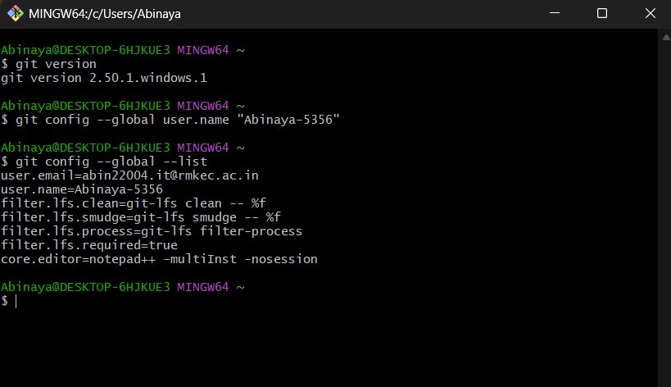

Step 2: Integrate notepad++.exe to Git and make it a default editor

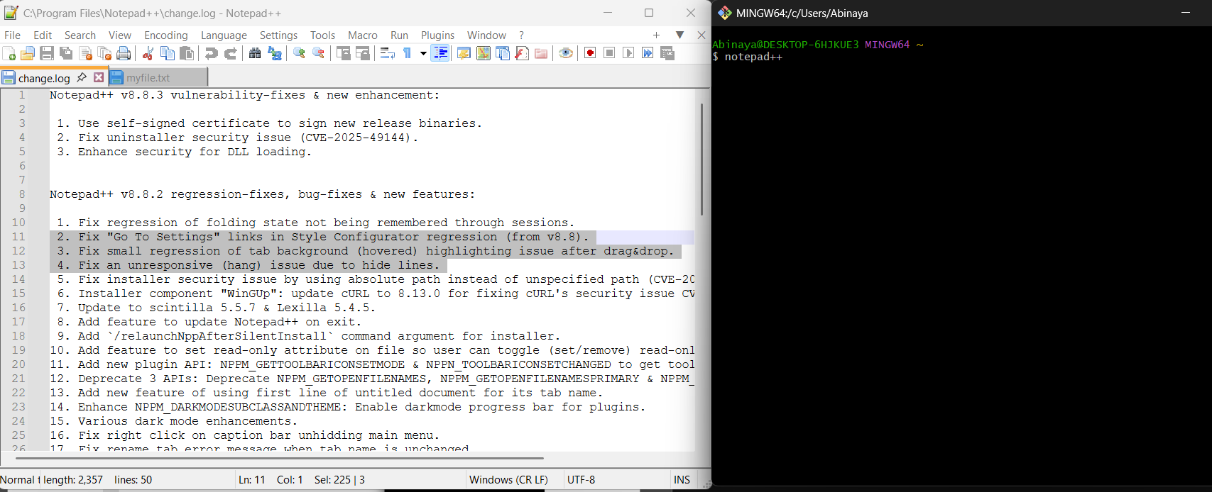

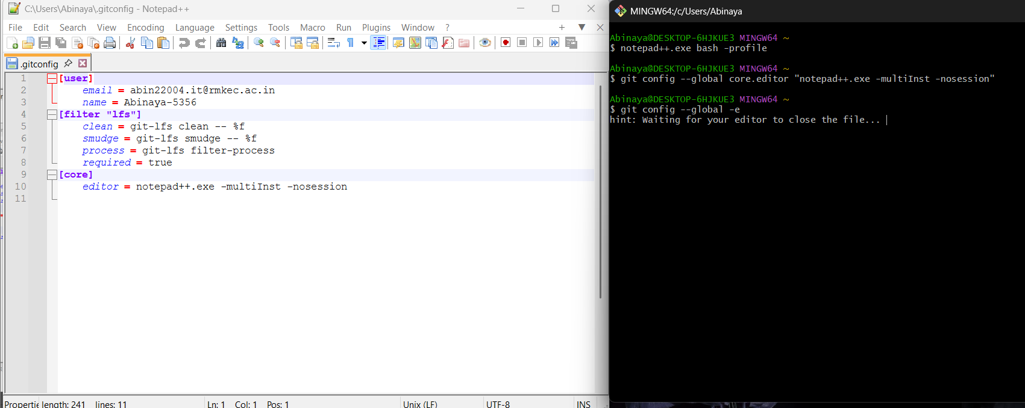

**S**tep 3: Add a file to source code repository

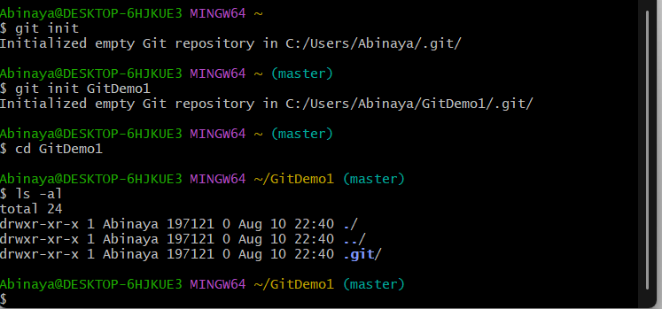

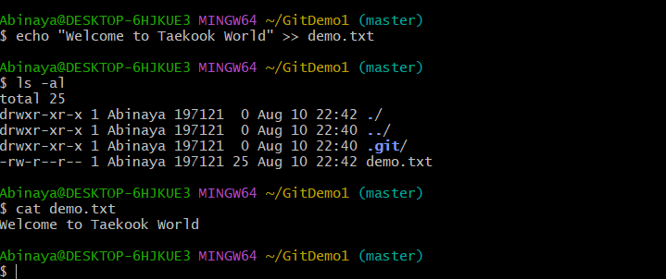

To check if local and “Working Directory” git repository are same, execute git status

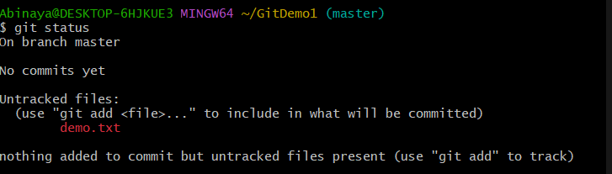

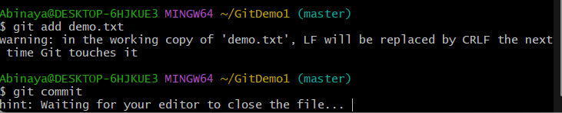

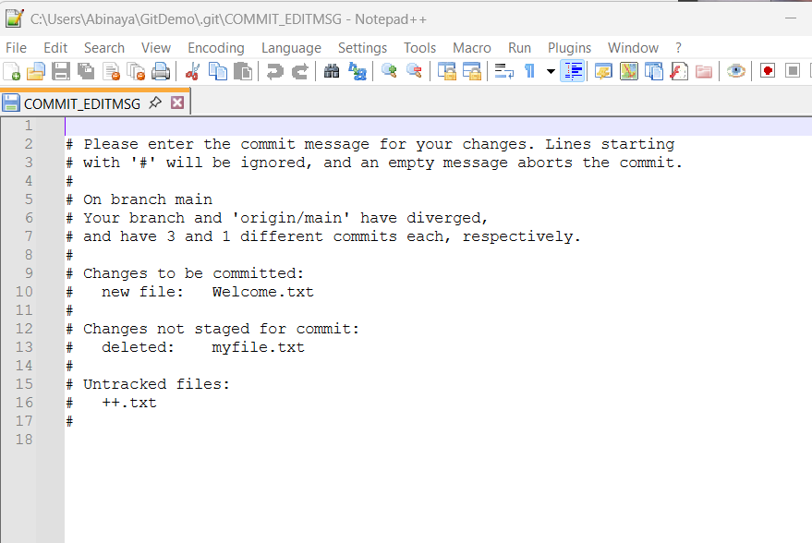

* Signup with GitLab and create a remote repository **“GitDemo”**
* To pull the remote repository, execute
* git pull origin master
* To push the local to remote repository, execute
* git push origin master

